**Exercises:**

*Using the member of <string> library

The abbreviation for state name is the first letter of each word in the state name in uppercase.

But if the name if only one word then its abbreviation is the first two letters in uppercase.

Write a program to read a state name and display its abbreviation.

(Assume the state name is less than or equal to 3 words)

Sample output:

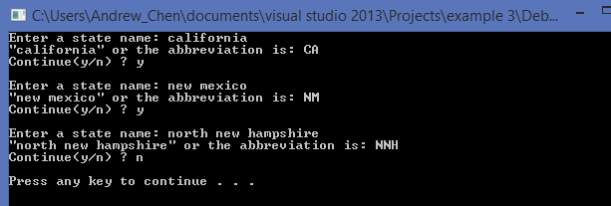

*If there is one space in the input string, it means two words include.

If there are two space in the input string, it means three words include.

So you can try to find the space by using .find() function (which is in <string> library